Chapter 3:
Contacts and Documents

Objectives

After completing this section, you will be able to:

- Add / Update / Delete / Search Companies
- Add / Update / Delete / Search Individual Contacts and TME Users
- Add / Update / Delete Cabinets, Drawers, and Folders
- Add / Update / Delete Documents

Contents
Contacts 72
Companies 72
Contacts 74
Departments 75
Access, Email and Certification Groups 76
Documents 77
Adding a Cabinet, Drawer and Folder 77
Adding Documents 81
Figure of Tables
Figure 1 Companies Viewer 72
Figure 2 Company Detail Screen 73
Figure 3 Contacts Viewer 74
Figure 4 Contact Detail Screen 74
Figure 5 Departments Viewer 75
Figure 6 Documents Browser 77
Figure 7 Cabinet Detail Screen 78
Figure 8 Drawer Detail Screen 78
Figure 9 Drawer - Permissions Detail Screen 79
Figure 10 Folder Detail Screen 80
Figure 11 Document String 80
Figure 12 "Are you sure...? Delete Screen 81
Figure 13 Document Detail Screen 82

Contacts

The Contacts module provides a convenient way to organize all your contacts such as maintenance contractors, suppliers and technical support numbers. It is also where the TME Users are set up.
It consists of four submodules, Companies, Contacts, Departments and Groups. The Companies submodule contains the contact information of a company or organization whereas the Contacts submodule contains the contact information of individuals. Departments manages the drop-down list of Departments while Groups is used to set up system access/permissions, certifications and email groups (Groups is discussed in the Settings Chapter).

Companies
This SubModule stores information on various companies as opposed to individual contacts. Before entering, have address, phone and category/subcategory information on hand. Categories may be set up as Vendor, Client/Customer, Contractor, Consulting Firm, etc. Examples of Sub-Categories for Vendor might be Office Supplies, Software, Equipment, Chemicals, and Instruments.

This SubModule provides the drop-down lists for Asset manufacturers and Inventory suppliers.

Exercise 1:
 Add New Companies

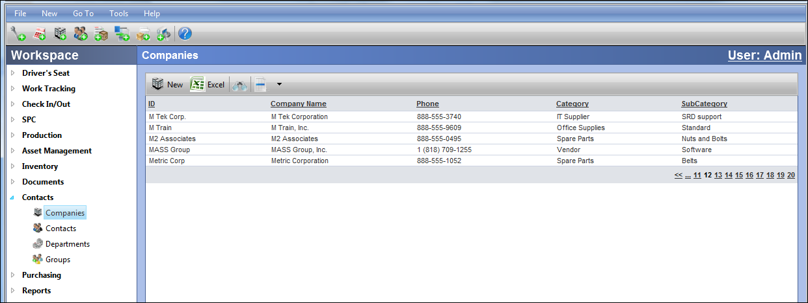
- Go to Contacts > Companies
Click .
Figure 1 Companies Viewer

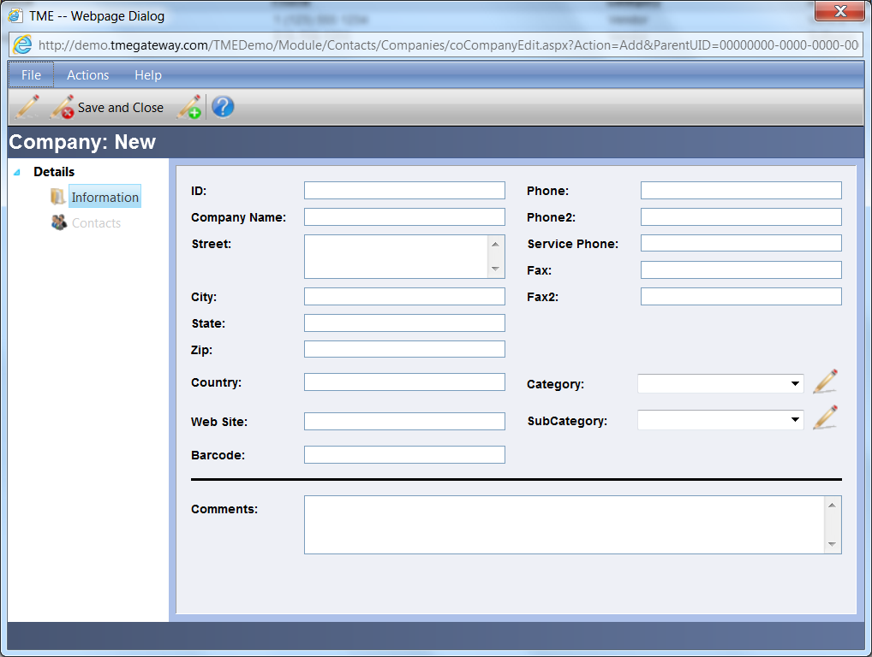
Figure 2 Company Detail Screen

- Enter information for all applicable fields. Select Category/SubCategory from the drop down menus or enter a new one into the drop down menus by clicking on the Enter New Item icon and typing them in.
- Save/Close
- Repeat and add two companies with different Categories and Sub-Categories.
- Repeat and add one company with the same Category and Sub-Category as one of the companies just added (use drop down menus).

All Contacts with a specific Company ID selected will appear in the Contacts viewer in the Details screen of that Company. The Contacts viewer is accessed by clicking on the Contacts link of the Details screen. The Contacts Details screen can then be accessed by double clicking anywhere within the row of the specific Contact or by right clicking on that row and selecting "View." The Contact information can be searched, sorted, exported to Excel, edited and saved in the same manner as if it had been accessed via the Contacts Viewer within the Contacts submodule.
To add a Contact within the Detail screen of a Company, click on the Contacts link. The Contacts viewer will appear, though it will not have any viewable records as it is filtered to show only those individuals who are associated with this company or organization. Click on the New Contact icon at the left side of the Viewer toolbar. Type in information and make selections accordingly. Save using the Detail Toolbar or Taskbar. The record for the Contact is now available.

Contacts
Whereas the Companies SubModule contains information on companies; the Contacts Sub-Module contains information on individuals and TME Users. Before entering, have address, phone and category/subcategory information on hand.

Exercise 2:
Add New Contacts

1. Go to Contacts > Contacts

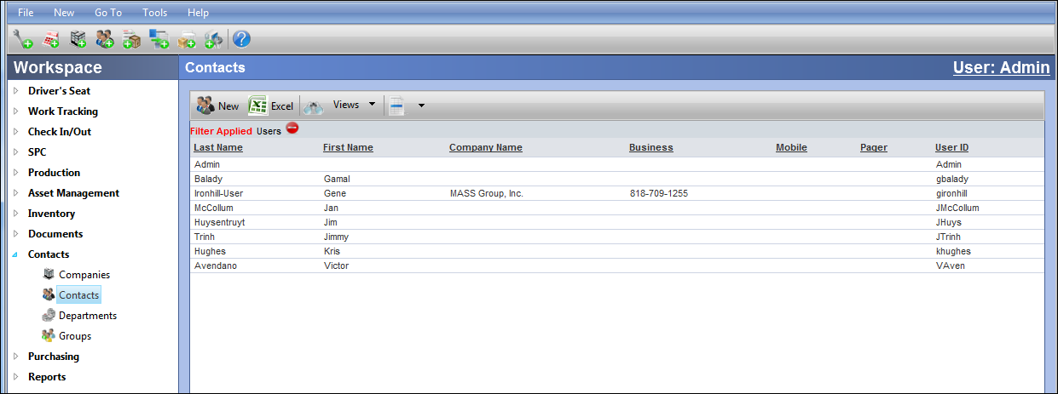
Figure 3 Contacts Viewer

- 2. Click .
- 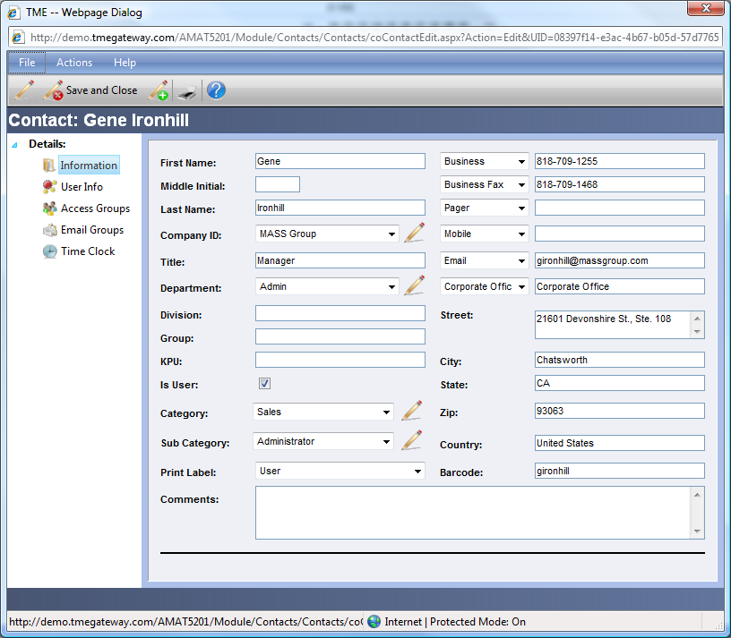
Figure 4 Contact Detail Screen
- Enter information for all the fields. Select a Category, SubCategory, and/or Department from the drop down menus or enter a new one into the drop down menus by clicking on the Enter New Item icon and typing them in. If “Is User” checkbox is selected, additional links for Access Groups, Email Groups and Time Clock Data will become available upon saving. If not, only the Email Groups link will be available. Additional details for the set up of TME Users and the additional links are in the Settings Chapter.
- Save/Close
- Repeat and add two Contacts with different Categories and Sub-Categories and change the Business and Home fields using the drop down menus.
- Repeat and add one Contact with the same Category and Sub-Category as one of the contacts just added (use drop down menus). Add a second address.

Exercise 3:
Edit / Delete a Company and a Contact

- Starting at the Company and Contact viewers, edit a company and a contact by changing the name of each.
- Starting at the Company and Contact viewers, delete a company and a contact.
- Add a Contact to a Company via the Company Detail screen.

Departments
Users (especially subcontractors) may belong to different departments for which work is to be charged. This feature is designed to allow users to select the department that needs to be charged from a managed drop down list.
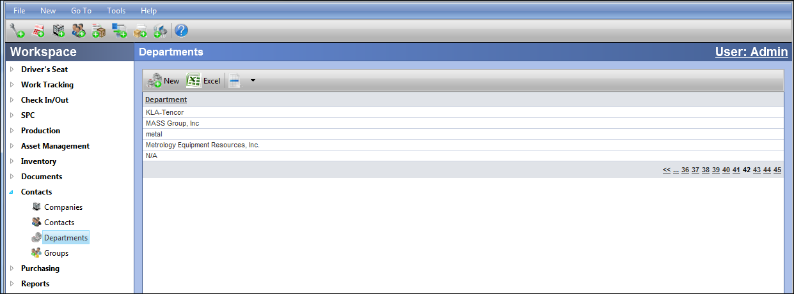
Figure 5 Departments Viewer
New Departments can be added by clicking on . Type in the Name/Number of the Department. Save.
Access, Email and Certification Groups
The Groups submodule is utilized to assign Contacts and Users to Email, Access and Certification Groups.

The Access Group provides a means for assigning Users their permissions to conduct certain tasks and access to specific features and/or objects. It is also used in conjunction with the WIP module to limit the ability of Users to start/stop equipment if membership in one of (or in all) required Access Groups is not up to date. Also, if a User is not associated with one or more Access Groups, then he/she will not have access to anything in TME.

The Email Group is set up to work with the Notifications feature throughout TME. Notifications can be associated to trigger and send out alerts to members of an Email Group as opposed to individual Contacts. Should a Contact need to be removed from a series of Notifications, he/she can simply be removed from the Email Group as opposed to having to open the Notifications screen for each object.

The Certification Group is utilized to track certifications/trainings/licenses for Contacts and provides notifications alerting designated Users when a certification is about to or has expired. It can also used in conjunction with the WIP module to limit the ability of Users to start/stop equipment if the Certification is also set up as an Access Group which is tied to a work flow (or portion thereof).

Details regarding the setting up of Groups and associating Contacts is provided in the Section 10 – Settings chapter.

Documents

The Documents module provides a convenient way to organize all your documents and media files such as maintenance checklists, warranty information, how-to videos, etc. This module can be accessed via Go To from the Task Bar or the appropriate Menu Group.
TME is designed to follow the structure of filing cabinets with a cabinet that contains drawers, drawers that contain folders and folders that hold documents (Word documents, Excel spreadsheets, image files, PDF files, etc.). Each structure consists of a drop-down menu that allows the user to select from a list. Upon making a selection, all other dependent menus change accordingly.
Users are then able to attach documentation from the Detail Screen of an item (such as an Asset) by clicking on the Documents link on the Detail Screen, selecting the appropriate Cabinet, Drawer, Folder and Document and then clicking on Add Document. Previewing the document prior to attaching is accomplished by clicking on the Preview link.
Permissions to view and/or attach documents throughout TME are set at the Drawer level and are based on Access Groups.
Documents can also be uploaded or linked via URL directly to objects (Assets, Inventory Items, Work Orders, etc.) when Document Attributes have been set up for those objects. See Chapter 10 Settings for details on Attribute setup as well as the Data Collection section of Chapter 1 Introduction and Overview.

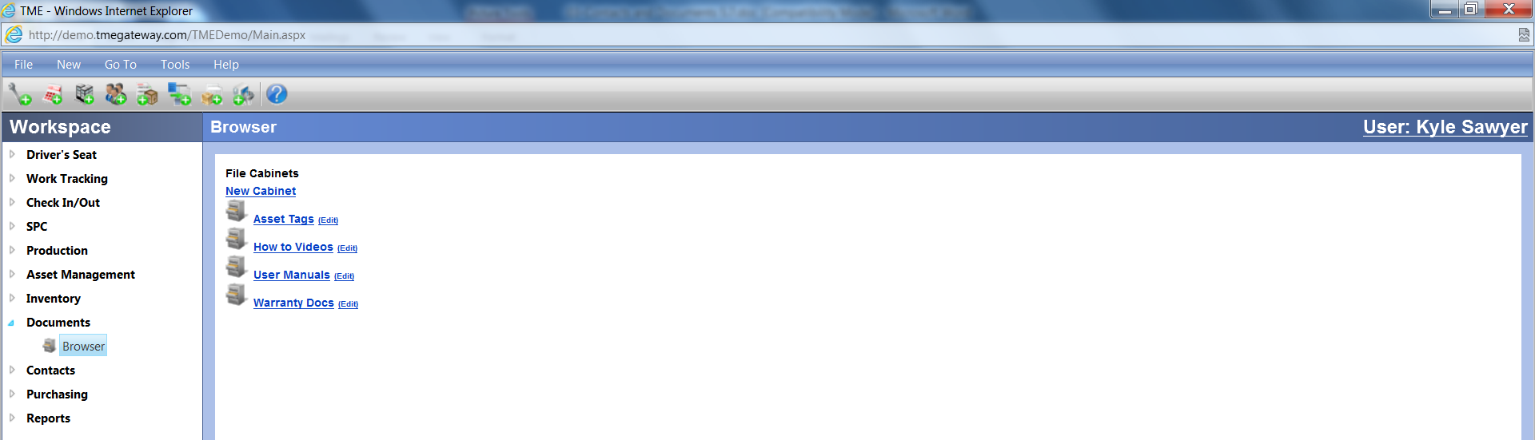
Figure 6 Documents Browser

Adding a Cabinet, Drawer and Folder

Exercise 4:
Create a Cabinet, Drawer and Folder.

- Go to Documents > Browser
- Click.

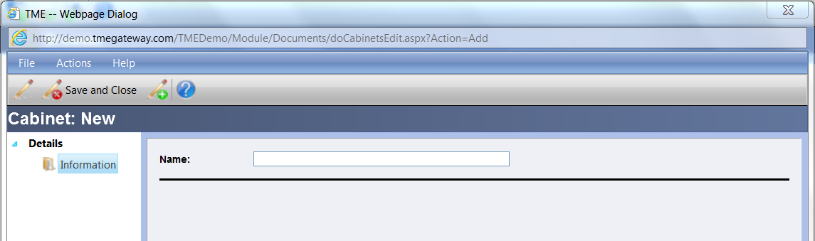
Figure 7 Cabinet Detail Screen

- Enter the Cabinet Name.
- Save / Close.
- Click on the Cabinet Name.
- Click.

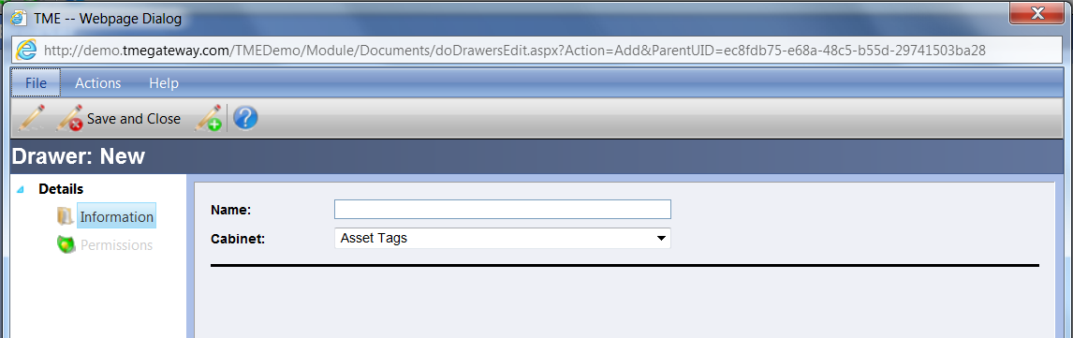
Figure 8 Drawer Detail Screen

- Enter the Drawer Name.
- Save (do not Save/Close)—the Permissions link will activate.
- Click on Permissions

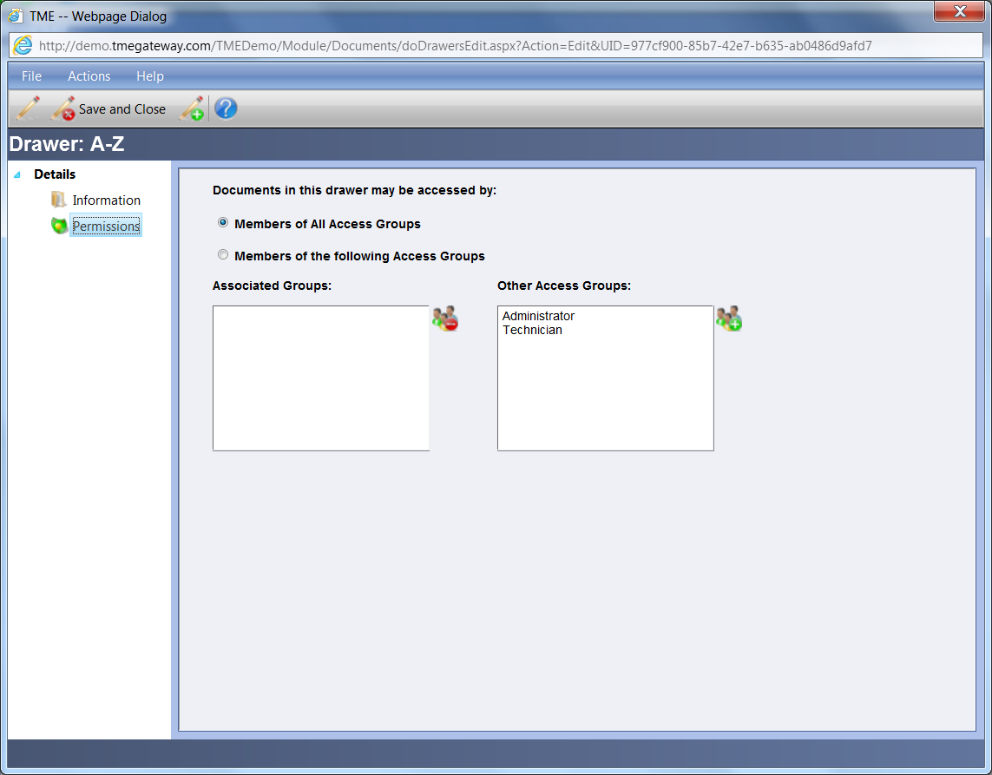
Figure 9 Drawer - Permissions Detail Screen

- Select the Access Groups (hold the Ctrl key if making multiple selections) from the Access Groups field and click on the Add Access Group icon to the right of the field. The groups selected are now visible in the Associated Groups field. To remove the User from an Access Group(s), select the Access Groups (hold the Ctrl key if making multiple selections) from the Associated Groups field and click on the Remove Access Group icon to the right of the field.
- Click Save/Close.
- Click on the Drawer Name.
- Click.

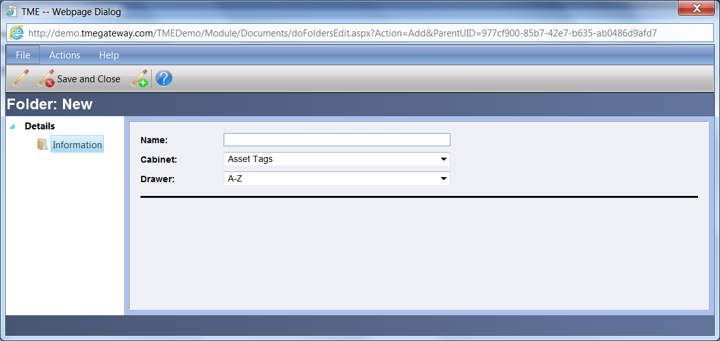
Figure 10 Folder Detail Screen

- Enter the Folder Name.
- Save/Close.
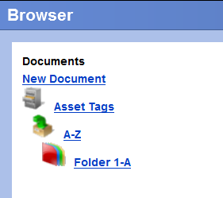
Figure 11 Document String

- Repeat and add another string of Cabinets through Folders with two of each in the string.

Editing a Cabinet, Drawer and Folder

The same process applies for editing a Cabinet, Drawer and a Folder.

Exercise 5:
Edit a Cabinet.

- Click next to the Cabinet to be edited.
- Enter the new Cabinet Name.
- Save/Close.

Deleting a Cabinet, Drawer and Folder

The same process applies for deleting a Cabinet, Drawer and a Folder.

Exercise 6:
 Delete a Cabinet.

- Click next to the Cabinet to be deleted.
- Go to Actions on the Taskbar and select “Delete Cabinet”
- Pop-up window appears.
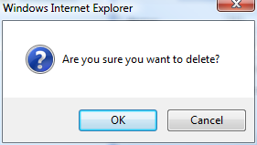
Figure 12 "Are you sure...? Delete Screen

- 4. Click .

Adding Documents

To attach a new document, click on the folder name where you want to attach the document. Then click .

Exercise 7:
Add a Document.

- Go to Documents.
- Click on the Cabinet, then the Drawer, then the Folder.
- Click .

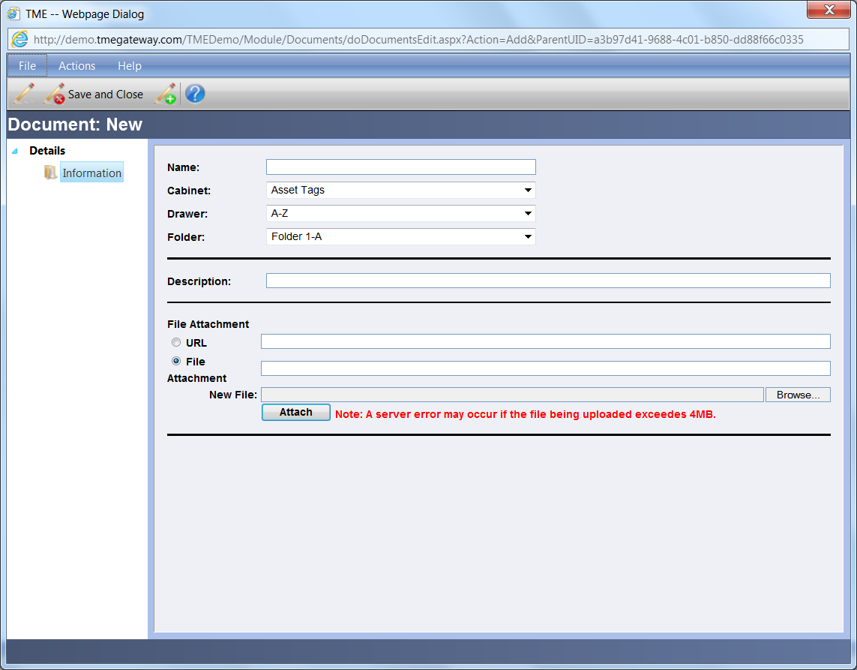
Figure 13 Document Detail Screen

- Enter the Name (this is the name that will be displayed throughout TME) of the document and the description of the document.
- Select URL or File.
- If File: Click to locate the document, click to attach the
document.
- If URL: type in address or paste link.
- Save/Close.

Exercise 8:
Edit and Delete Documents.

- Edit names of two documents and delete two documents.

